PROGRAMMING FUNDAMENTAL(LAB)

Semester Final Project

**Title: *Transport Management System Implementation Report***

# Group Members:

* Maaz Sajid 23k-0042
* Muhammad Salih Soomro 23i-2042
* Mohammad Umar khan 23k-3019

**Introduction:** The purpose of this project is to design and implement a Transport Management System using C programming. The system is aimed at facilitating communication between transport administrators, users, and disseminating notices effectively.

**Background:** The decision to develop this Transport Management System arose from identified challenges in existing transportation systems, including inadequate communication channels and inefficiencies in managing transport-related information.

**Project Specification:** The system consists of three primary modules: 1. Admin Login

1. User Login
2. Notice Feature

# Problem Analysis:

* Inefficient communication between transport administrators and

users.

* + Lack of a centralized system for managing transportation-related information. ∙ Absence of user-friendly interfaces for transport operations.

# Solution Design:

1. **Admin Login**:
   * **Functionality**: Enables transport administrators to access privileged system features.

# Features:

* + - **Manage Vehicles**: Add, update, or remove vehicles from the system. ∙ **Notice Management**: Create, edit, and delete notices for user display. 2. **User Login**:
* **Functionality**: Allows users to interact with the system.

# Features:

* **Vehicle Details**: Access information about available vehicles.
  + **Route Information**: View predefined route details.
    - **Seat Booking**: Reserve seats in available vehicles for specific routes. 3. **Notice Feature**:
* **Functionality**: Facilitates notice dissemination within the system.

# Features:

* **Notice Display**: Presents Admin-created notices to users.
  + **Real-time Updates**: Manages notice updates or removal for user display.

# Data Handling:

* + **File Operations**: Utilizes file handling for storing and retrieving vehicle, notice, and user data.
* **Data Integrity**: Ensures security and integrity of stored data.

# Implementation and Testing:

* + Developed the system using C programming language.
  + Employed file handling for data storage.
  + Implemented functionalities for adding vehicles, displaying details, and managing notices.
  + Used Structure array to store multiple type data of the vehicles. ∙ Conducted rigorous testing to ensure functionality and address potential issues.

# Project Breakdown Structure:

* + **Task Breakdown:**
    - Task 1: Develop Admin Login Module.
    - Task 2: Implement User Login Functionality.
    - Task 3: Design and Implement Notice Feature.
    - Task 4: Conduct Testing and Debugging.
    - Task 5: Establish Data Handling Procedures.
    - Task 6: Documentation and Report Writing.

# Workload Distribution:

All the tasks are mutually carried out by all the group members. ∙ **Timeline:**

**Started**: 24-Nov-2023

**Ended**:27-Nov-2023 **Output Screenshots:**

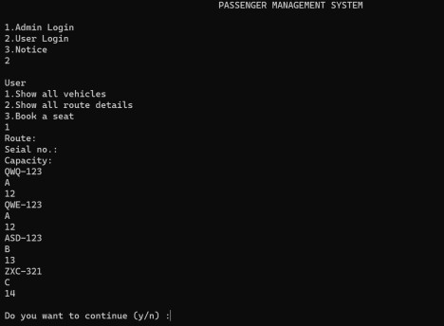

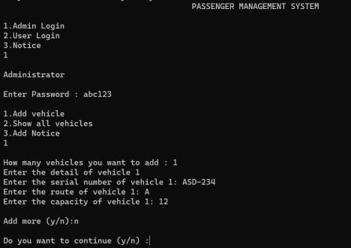

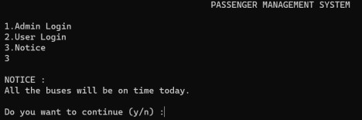

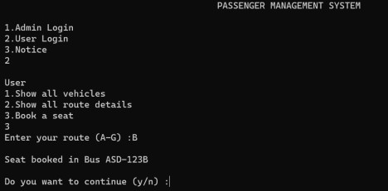

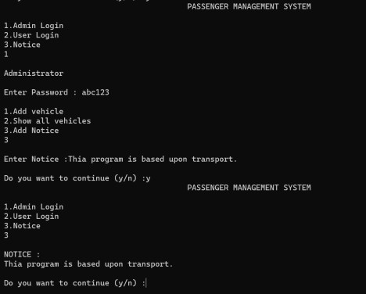

# Conclusion:

The Transport Management System developed in C programming effectively addresses the identified challenges by providing a user-friendly interface for managing transportation

activities. It allows administrators to manage vehicles and notices, while users can access vehicle details, route information, and book seats.